College Student

Representation at Hartpury



**Your Student Rep** Handbook

Hello and Welcome!



It’s fantastic to have you on board as one of the college Reps at Hartpury!

The representation system is run in partnership between Hartpury College and Hartpury Students’ Union and is vital in championing the voice of students.

The work you do is vital in improving the students experience here at Hartpury – both in the classroom and beyond.

With your help we can ensure that all students – current and future – get the most out of their time at Hartpury.

We hope you find this handbook useful as a resource to refer to but if you need to get in touch please don’t hesitate to do so! You can pop into the SU office, find us on Facebook and Instagram or email me at [Andrew.Shattock@hartpury.ac.uk.](mailto:Andrew.Shattock@hartpury.ac.uk.)

All the best!

*Andrew*

Hartpury Students’ Union Representation Officer

Contents

**Title Page**

Introduction 4

Welcome to the world of student representation 4

The role of Student Reps 4

Rules, Responsibilities, and Boundaries 5

Your role 5

Your responsibilities 5

Your boundaries 5

Promoting yourself 6

Meetings 6

Before 6

During 7

After 7

Meeting structure at Hartpury 7

Meeting summaries 8

Additional resources 9

Signposting students 9

Issue decision tree 11

Impact Report for Representation 2023/2024 12

Introduction

Welcome to the world of Student Representation

Welcome to the Student Representation Team!

You're now part of a group of more than a hundred student representatives (Reps) at both the college and university levels. Our goal is to amplify your voice as a student.

We've created this handy guide to help you in your role throughout your time at Hartpury. Inside, you'll discover valuable insights about what Reps do and how Hartpury Students’ Union (HSU) supports students like you in making a difference.

Reps play a crucial role in improving the student experience. You'll collect feedback about academics and collaborate with staff regarding improvements. Additionally, you'll gather input on the broader student experience, working closely with HSU.

We'll carefully review the feedback and ideas you collect, working together to implement positive changes that enhance your degree experience and ensure you have a fantastic time at Hartpury.

The role of Student Reps

As a Rep at Hartpury, your mission is to be the voice of your fellow students and work hand in hand with both students and staff to improve our campus experience. You'll gather feedback, share ideas, and collaborate with Hartpury and HSU.

You'll also have the chance to get involved in campaigns and projects driven by student input. Occasionally, departments will seek your input for new initiatives, emphasising the importance of student-led decision-making.

Reps have played pivotal roles in decisions during lockdown and the return to campus. They've helped shape inclusive teaching, allocate study spaces, and even establish Hartpury University Academic Regulations. Be part of the exciting changes at Hartpury!

Roles, responsibilities, and boundaries

Your role

To represent students on your course and in your year. You’ll be bringing feedback, suggestions, and questions to HSU and to Hartpury College.

**College** **students**: We ask all Reps to self-register on the Student Rep database, so make sure you do that as soon as possible. Your tutor should have sent you the link. If not, please contact the Rep Coordinator, Ellie (Ellie.Martin2@hartpury.ac.uk).

Your Responsibilities

* Attend the Rep training
* Make sure that the students you represent know who you are and how they can contact you
* Attend core representative meetings e.g. SU Rep Forums
* Be proactive in seeking out students’ views on matters relating to their experience at Hartpury, both positive and negative
* Be on time and prepared for all meetings
* If you are unable to attend meetings, send your apologies to the Rep Coordinator (including the reason for your absence) in advance of the meeting along with feedback which you have gathered for the meeting
* Be truly representative in meetings you attend; representing the views and experiences of the students you represent beyond your own perspective
* Promote respectful dialogue and uphold freedom of speech
* Raise student feedback issues with the SU as they arise
* Relay outcomes which have come as a result of issues raised to your cohort
* Share key messages with your cohort
* Regularly communicate with the Representation Officer
* Appropriately signpost students to sources of support when they raise individual queries
* Engage in activities which promote and celebrate the role of Reps
* Abide by the behavioural expectations outlined in the SU Code of Conduct (work in progress but expectations can be discussed upon request)
* Seek support from the Students' Union in times of need and be assured of your right to withdraw if faced with challenges, including instances of bullying

Your Boundaries

**Student disciplinary matters:** students who have concerns in this area should be referred to the Representation officer - Reps don’t represent students in disciplinary matters.

**Complaints:** if students wish to make a formal complaint, they should be referred to the Complaints Policy. Signpost students to the Student Advisors or your tutor for help.

**Personal problems:** signpost students to the appropriate support service on campus – the Wellbeing Team can help them from there.

Promoting Yourself

Here’s some ways to let your students know you are their rep for the year:

* Ask your college tutor to send an email around on your behalf to all students introducing you and your role.
* Create a social media group introducing yourself as a Rep on that. It’s a good idea to check first to see if a group or group chat already exists!
* Ask if you can do a quick shout out in a lecture or group tutorial session.
* You might need to do these things again ahead of your Rep meetings to remind your group.

Meetings

Reps are invited to HSU and College meetings and this section of the handbook will set out what different meetings are held and how you can be effective in them.

There will always be someone, usually the Rep Coordinator if it’s a meeting organised by the SU, taking notes (the ‘minutes’) at a meeting which will record what was discussed and who was present.

Attending meetings is a fantastic way for student reps to make a difference, and you absolutely belong there! Here are some friendly tips:

Before the Meeting

* Take a quick peek at past meeting notes (if they're available).
* If you've got ideas, suggest them for the agenda.
* Chat with your peers to gather their thoughts.
* Make sure you know when and where the meeting is happening.
* Life happens; if you can't make it, just give the meeting organiser a heads-up and share the feedback you've gathered.

During the Meeting

* Try to be on time, or even a little early if you can.
* Don't forget your meeting materials.
* Be positive and share your thoughts constructively.
* Feel free to ask questions, keep eye contact, and jot down anything important.
* Remember, your voice matters as much as anyone else's!

After the Meeting

* Keep a reminder of what you need to do next.
* If something's not quite right, don't hesitate to chat with the President of Representation.
* Share meeting outcomes with your fellow students in a way that suits you best.

Participating in meetings is your chance to shine and help make things better. So, be yourself, stay prepared, and stay involved!

Meeting structure at Hartpury

The above meetings do not require college student representation, but it is still useful to see how university reps and officers get involved!

Meeting Summaries

|  |  |  |  |
| --- | --- | --- | --- |
| **Meeting** | **Who attends?** | **How often?** | **What does it deal with?** |
| College Rep Training* | All College Reps | Once a year | Provides Reps with the knowledge and understanding on how to perform in their role |
| HSU College Rep Forum* | All College Reps  Representation Officer  Rep Coordinator | 3 times a year | All student experience matters not relating to the academic experience |
| Executive Meeting* | All College reps  College Senior Management | 3 times a year | An opportunity to discuss aspects of academic provision with members of the Senior Management Team |
| Student Council | Elected Student Reps  All HSU Officers  Clubs and Societies Committee Members | 3 times a year | Helping the Executive Committee carry out their work and holding them accountable  Setting Hartpury Students’ Union policies  Acting as a consultation forum for raising matters with Hartpury University and Hartpury College |
| Health and Safety Forum | 1 Student Rep  Chief Operating Officer (Chairperson), Health & Safety Manager (Vice Chair), Forum Secretary, Director of Facilities, Sports Academy Facilities Manager, Equine Director , Subject Leader Agriculture, Farm Manager, Head of Property , Animal Director, Head of Residential Support/PREVENT lead, Laboratory Manager, FE Sport, Outdoor Adventure & Uniformed P.S, Head of Student Experience, HE Agriculture Lecturer | 4 times per year | 1. To provide a focal point and source of expertise for Hartpury University and Hartpury College, (Hartpury) its employees and students on health and safety issues. 2. To consult and represent staff on health and safety issues. 3. To provide a statutory H&S consultation forum for union safety representatives and staff representatives under The Safety Representatives and Safety Committees Regulations 1977 and The Health and Safety (Consultation with Employees) Regulations 1996. |
| Sexual Harassment and Misconduct Forum | 2 College and 2 University Reps  Mix of academic staff both FE & HE and Professional Services staff. | 4 times per year | As a College & University there are duties imposed upon us by OFSTED and Office for Students to ensure we have zero tolerance of sexual harassment on our campus. At the meetings they discuss how we can raise awareness across both college & university students and what actions can put in place to support this. |
| Mental Health and Resilience Steering Group | 2 College and 2 University Reps  Mix of academic staff both FE & HE and Professional Services staff. | 4 times per year | They review actions in line with our MH action planner which feeds into our MH & Wellbeing strategy. It also supports our continuing journey as a University that has the student minds university charter. They have also signed the AOC MH charter. Actions in support of this are discussed at the meeting. Wellbeing is one of the cross-cutting themes for Hartpury 2030 Strategy therefore it is important we hear the student voice. |
| Race Equity Task group | 1 College and 1 University Rep (they are especially looking for Reps from minority ethnic groups)  A collection of Hartpury staff from College, University and Professional Services | 3-4 times per year | They discuss activity under five key areas (Training for all, Demystifying EDI terminology, Celebrating diversity with students, Corporate ownership, Focus in EDI in teaching). This year they will be specifically working towards obtaining the Trailblazer Award through Race Equality Matters. |
| Sustainability Steering Group | 1 College and 1 University Rep  Key staff representatives across the organisation – College, University and Professional services | 5 to 6 times per year | Updates on sustainability initiatives on campus, upcoming projects, challenges, and training opportunities. |

*Core responsibilities in which Reps are expected to attend

Additional resources

Signposting Students

Below is a list of contacts that you can share with students if they are unsure who to go to for help.

**Accommodation**

Accommodation@Hartpury.ac.uk

01452 202352

**Health and Wellbeing**

Wellbeing@Hartpury.ac.uk

01452 202327

**Innovation, Careers and Enterprise (ICE)**

[Careers@hartpury.ac.uk](mailto:Careers@hartpury.ac.uk)

**Student Services**

studentservices@hartpury.ac.uk

01452 702109

**Safeguarding**

[safeguarding@hartpury.ac.uk](mailto:safeguarding@hartpury.ac.uk)

07788 148358

**Residential Support Team**

Residentialsupportteam@hartpury.ac.uk

07768 091041

**Students Union**

StudentsUnion@Hartpury.ac.uk

01452 702374

Sophie Savage (HSU Manager) [Sophie.Savage2@hartpury.ac.uk](mailto:Sophie.Savage2@hartpury.ac.uk)

Ellie Martin (Representation Coordinator) [Ellie.Martin2@hartpury.ac.uk](mailto:Ellie.Martin2@hartpury.ac.uk)

Sascha Bruce (Activities Coordinator) [Sascha.Bruce2@hartpury.ac.uk](mailto:Sascha.Bruce2@hartpury.ac.uk)

Andrew Shattock (Representation Officer) [Andrew.Shattock2@hartpury.ac.uk](mailto:Andrew.Shattock2@hartpury.ac.uk)

Emily Pitman (Clubs and Societies Officer) [Emily.Pitman2@hartpry.ac.uk](mailto:Emily.Pitman2@hartpry.ac.uk)

Morgan Hanif (Guidance Officer) [Morgan.Hanif2@hartpury.ac.uk](mailto:Morgan.Hanif2@hartpury.ac.uk)

Sammy Coombs (LGBT+ Students’ Liberation Representative) [Sammy.Coombs@hartpury.ac.uk](mailto:Sammy.Coombs@hartpury.ac.uk)

Aja Whittingham (Disabled Students’ Liberation Representative) [Aja.Whittingham@hartpury.ac.uk](mailto:Aja.Whittingham@hartpury.ac.uk)

Issue Decision Tree

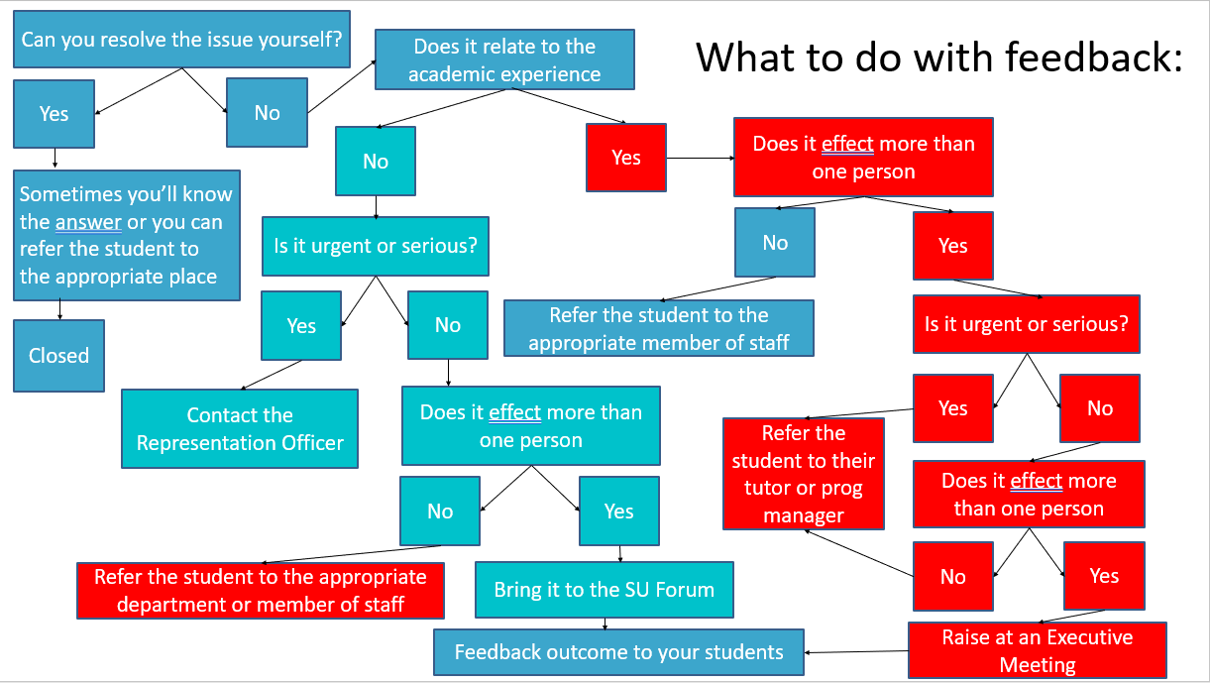

Impact Report for Representation 2023/2024

